**Iteration 1 Plan actual**

**Phase: Elaboration Iteration:1 Start Date: Oct. 30, 2019 End Date: Nov 8, 2019**

|  |  |  |  |  |  |
| --- | --- | --- | --- | --- | --- |
| **Core Workflows/ Disciplines** | **Use Case/ Requirements** | **Activity/ Task** | **Time**  **(hours)** | **Actual Time(hours)** | **Resources(role)** |
| Requirement | Books tee times  Submit standing tee time request | Primary Scenario Books tee times (Player-Gold)  Write Scenario  Primary Scenario  Submit standing tee time request (Player-Gold)  Write Scenario | 2  2 | 3  3 | 1 Use case Specifier |
| Analysis | Books tee times  Submit standing tee time request | Primary Scenario Books tee times (Player-Gold)  Domain Model  Primary Scenario Submit standing tee time request (Player-Gold)  Domain Model | 2  2 | 3  2 | 1 System analyst |
| Design | Books tee times  Submit standing tee time request | Primary Scenario Books tee times (Player-Gold)  Interaction Diagram, Design Class diagram  Primary Scenario Submit standing tee time request (Player-Gold)  Interaction Diagram, Design Class diagram | 3  3 | 3  3 | 1 Use case Engineer |
| Implement | Books tee times  Submit standing tee time request | Primary Scenario Books tee times (Player-Gold)  Implementing Object Oriented Design  Primary Scenario Submit standing tee time request (Player-Gold)  Implementing Object Oriented Design | 4  4 | 5  5 | 1 Component Engineer |
| Test | Books tee times  Submit standing tee time request | Primary Scenario Books tee times (Player-Gold)   * Testcase * Test Procedure * Execution of test   Primary Scenario Submit standing tee time request (Player-Gold)   * TestCase * Test Procedure * Execution of test | 5  5 | 2  2 | 1 Test Engineer |
|  |  | **TOTAL:-** | 32 | 31 | 3 Use Case Specifiers  3 System Analysts  3 Use Case Engineers  3 Component Engineers  3 Test Engineers |

**Iteration 2 Plan**

**Phase: Elaboration Iteration:2 Start Date: Nov 13, 2019 End Date: Nov 26, 2019**

|  |  |  |  |  |
| --- | --- | --- | --- | --- |
| **Core Workflows/ Disciplines** | **Use Case/ Requirements** | **Activity/ Task** | **Time**  **(hours)** | **Resources(role)** |
| Requirement | Books tee times  Books tee times | Secondary Scenario  BooksTeeTime (Player-Silver)  Write Scenario  Secondary Scenario  BooksTeeTime (Player-Bronze)  Write Scenario | 2  2 | 1 Use case Specifier |
| Analysis | Books tee times  Books tee times | Secondary Scenario  BooksTeeTime (Player-Silver)  Domain Model  Secondary Scenario  BooksTeeTime (Player-Bronze)  Domain Model | 2  2 | 1 System analyst |
| Design | Books tee times  Books tee times | Secondary Scenario  BooksTeeTime (Player-Silver)  Interaction Diagram, Design Class diagram  Secondary Scenario  BooksTeeTime (Player-Bronze)  Interaction Diagram, Design Class diagram | 3  3 | 1 Use case Engineer |
| Implement | Books tee times  Books tee times | Secondary Scenario  BooksTeeTime (Player-Silver)  Implementing Object Oriented Design  Secondary Scenario  BooksTeeTime (Player-Bronze)  Implementing Object Oriented Design | 4  4 | 1 Component Engineer |
| Test | Books tee times  Books tee times | Secondary Scenario  BooksTeeTime (Player-Silver)   * Testcase * Test Procedure * Execution of test   Secondary Scenario  BooksTeeTime (Player-Bronze)   * TestCase * Test Procedure * Execution of test | 3  3 | 1 Test Engineer |
|  |  | **TOTAL:-** | 28 | 3 Use Case Specifiers  3 System Analysts  3 Use Case Engineers  3 Component Engineers  3 Test Engineers |

**Use Case Model**

Use Case: BooksTeeTime

Brief Description: The purpose of this use case is to allow players of ClubBAISTGolfSystem to book tee time.

Flow of Events

* Basic flow
* Use Case narrative

A Gold level ClubBAISTGolfSystem player wants to book tee time

A gold level ClubBAISTGolfSystem player provides the following:

* Date

When completed, Gold level ClubBAISTGolfSystem player submits the request to the system to view daily tee sheet. System processes the request and finds the tee sheet and returns tee sheet for that date to Gold level ClubBAISTGolfSystem player. After looking at available tee times, Gold level ClubBAISTGolfSystem player provides the following:

* Date
* Time
* NumberOfPlayers
* PlayerFirstName
* PlayerLastName
* PhoneNumber
* NumberOfCarts

After completing, Gold level ClubBAISTGolfSystem player submits the request for book tee time to the system. System then processes the request and books tee time and sends confirmation back to Gold level ClubBAISTGolfSystem player.

* Primary scenario narrative

Primary Scenario: Justin Thomas, a player of ClubBAISTGolfSystem, books tee time for Thursday June 25th, 2020 for 7 a.m. for himself.

Scenario: Justin Thomas, a Gold level player of ClubBAISTGolfSystem wants to books a tee time any time. Justin Thomas provides the following:

* Date: June 25th, 2020

When completed, Justin submits the request to the system to view daily tee sheet. System processes the request and finds the tee sheet and returns tee sheet for June 25th, 2020 to Justin Thomas. After looking at available tee times, Justin Thomas provides the following:

* Date: June 25th, 2020
* Time: 7 a.m.
* NumberOfPlayers: 1
* PlayerFirstName: Justin
* PlayerLastName: Thomas
* PhoneNumber: 7808011114
* NumberOfCarts: 1

After completing, Justin Thomas submits the request for book tee time to the system. System then processes the request and books tee time for June 25th, 2020 at 7 a.m. and sends confirmation back to Justin Thomas.

* Alternative flows
* Secondary/Alternate scenario narratives

Secondary Scenario: (Player, Silver) and (Player,Bronze) to be covered in iteration 2.

* Special Requirements :N/A
* Preconditions :Tee sheet is required
* Postconditions : Tee time was booked for June 25th, 2020 for 7 a.m. for Justin Thomas
* Other diagrams :
* System Sequence Diagram (SSD)

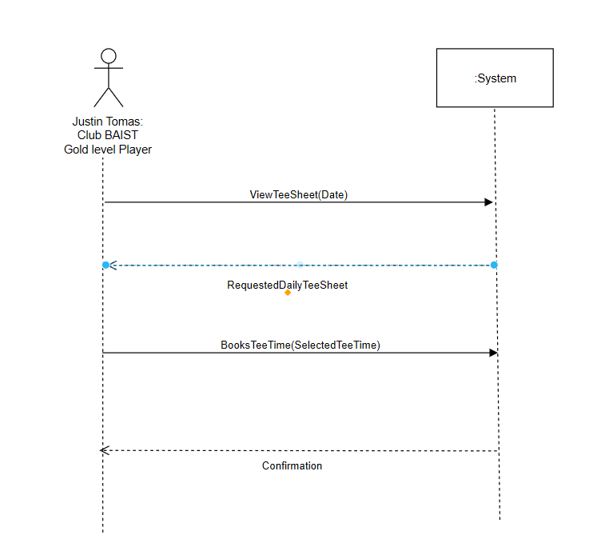

* User Interface Prototype

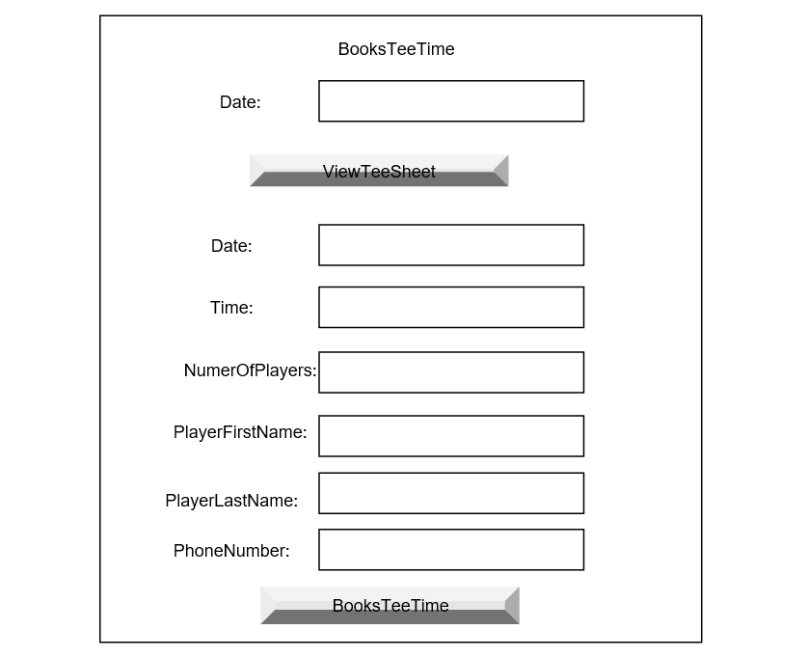

Use Case: Submits Standing Tee Time Request

Brief Description: The purpose of this use case is to allow shareholder members of Golf Club BAIST to submit standing tee time request.

Flow of Events

* Basic flow
* Use Case narrative

A shareholder member of ClubBAISTGolfSystem wants to submit standing tee time request

A shareholder member of ClubBAISTGolfSystem provides the following:

* Date

When completed, shareholder member submits the request to the system to view standing tee times by submittind View standing tee time request. System processes the request and finds standing tee times and returns standing tee timesfor that date to shareholder member. After looking at available standing tee times, shareholder member provides the following:

* MemberNumber
* MemberFirstName
* MemberLastName
* RequestedTime
* RequestedStartDate
* RequestedEndDate

After completing, shareholder member submits the request to book standing tee time to the system. System then processes the request and books standing tee time and sends confirmation back to shareholder member.

* Primary scenario narrative

Primary Scenario: David Toms makes standing tee time request for June 5th, 2020, Monday for 11 a.m. for himself.

Scenario: David Toms, a shareholder member of ClubBAISTGolfSystem wants to make one standing tee time request. For this, David Toms wants to view standing tee times. So, David Toms provides the following:

* Date: June 5th, 2020

When completed, Nick submits the request to the system to view standing tee times by submittind View standing tee time request. System processes the request and finds standing tee times and returns standing tee times for June 5th, 2020 to David Toms. After looking at available standing tee times, David Toms provides the following:

* MemberNumber: 11231
* MemberFirstName: David
* MemberLastName: Toms
* RequestedTime: 11 a.m.
* RequestedStartDate: June 5th, 2020
* RequestedEndDate: June5th, 2020

After completing, David Toms submits the request to book standing tee time to the system. System then processes the request and books standing tee time for June 5th, 2020, 11 a.m. and sends confirmation back to David Toms.

Alternative flows : N/A

Secondary/Alternate scenario narratives (if applicable)

Special Requirements :N/A

Preconditions : List of previously requested standing tee times .

Postconditions : Standing Tee time booked for June 5th, 2020 for 11 a.m. for David Toms.

* Other diagrams :
* System Sequence Diagram (SSD)

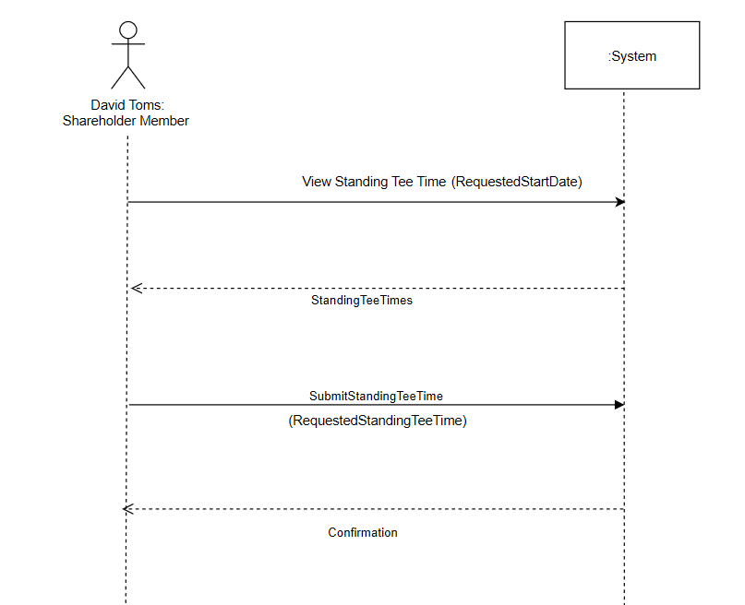

* User Interface Prototype

